

**LAB MANUAL**

**Academic Year-2023-24**

**Program: BTI Computer Engineering/ Data Science**

**Semester – III**

**Course: - Computer Hardware and Maintenance**

**LAB ASSISTANT FACULTY**

| **Course Faculties** | | | |
| --- | --- | --- | --- |
| **Course Faculty 1**  Dr. Seema Shah : | |  | |
| **Course Faculty 2** | | **Course Faculty 3** | |

**Lab Submission nomenclature:CHM_III_Div_RollNo**

**EXPERIMENT NO. 1**

**PART A**

**A.1 AIM: -**To get familiar with Computer System specifications

**A.2 Prerequisite**

Nil

**A.3 Outcome**

After successful completion of this experiment students will be able to

1. Understand various parts of the computer
2. List the specifications of a desktop/ laptop

**A.4 Theory**

To get familiar with Computer System specifications (Demo and Market Survey)

**Reading:** Reading manual - Chapter 1

**Task 1:**

Fill in the details in the following table after the demo:

**Table 1: Specification of Desktop PC**

| **Sr. No.** | **Part** | | | **Manufacturer** | **Specification** |
| --- | --- | --- | --- | --- | --- |
| 1 | Processor (CPU) | | |  |  |
| 2 | Operating System | | |  |  |
| 3 | Memory | | |  |  |
| 4 | Storage (Hard Disk) | | |  |  |
| 5 | Graphics Card | | |  |  |
| 6 | Display/Monitor | | |  |  |
| 7 | Hard Disk Drive | | |  |  |
| 8 | CD/DVD Drive | | |  |  |
| 9 | Keyboard | | |  |  |
| 10 | Mouse | | |  |  |
| 11 | Network Adaptor | | |  |  |
| 12 | HDMI / VGA Port | | |  |  |
| 13 | USB Ports | | |  |  |
| 14 | Card Reader | | |  |  |
| 15 | Any other | | |  |  |

**Table 2: Specification of Laptop**

| **Sr. No.** | **Part** | **Manufacturer** | **Specification** |
| --- | --- | --- | --- |
| 1 | Processor (CPU) |  |  |
| 2 | Operating System |  |  |
| 3 | Memory |  |  |
| 4 | Storage |  |  |
| 5 | Graphics Card |  |  |
| 6 | Display (LED/LCD) |  |  |
| 7 | Hard Disk Drive |  |  |
| 8 | CD/DVD Drive |  |  |
| 9 | Network Adapter |  |  |
| 10 | HDMI Port |  |  |
| 11 | USB Port |  |  |
| 12 | Wireless Network |  |  |
| 13 | Camera |  |  |
| 14 | Any other |  |  |

**Task 2:**

Label different parts of the Desktop Computer shown in Fig. 1

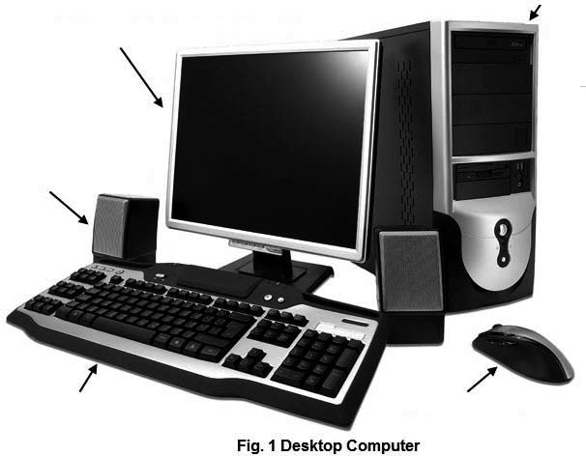

Label different parts of the Laptop shown in Fig. 2 in a slide.

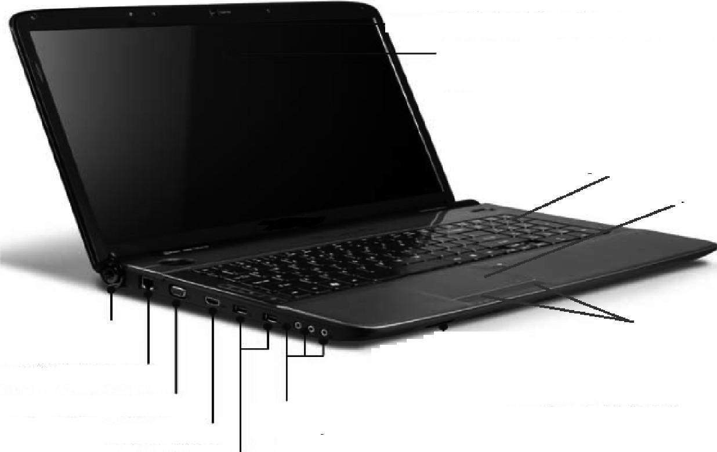

**Task 3:**

State the main function of each part of the computer that you have listed in table 1

**Task 4:**

Timeline of CPU :

For a specific manufacturer, illustrate the timeline of various generations of the CPU and the major difference in each generation. (last 5 generations)

**Task 5: (Practicum Segment)**

* Students need to go to the images below and select a mandatory component for Practicum.
* Every student needs to pick up a unique component

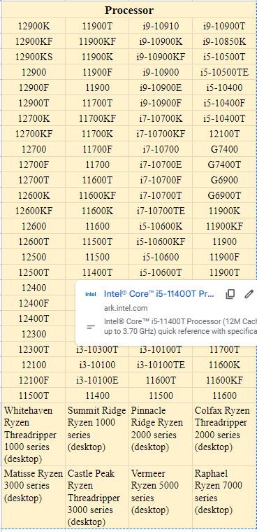

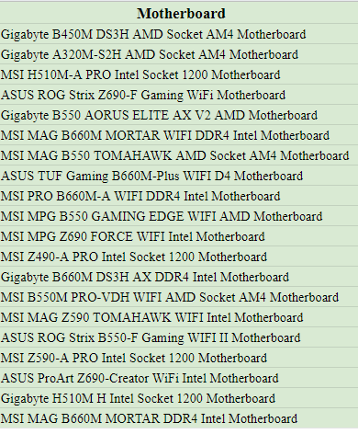

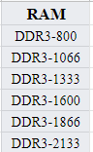

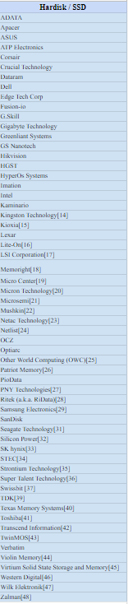

**PART B**

(PART B: TO BE COMPLETED BY STUDENTS)

**(Students must submit the soft copy as per following segments within two hours of the practical. The soft copy must be uploaded on the Blackboard or emailed to the concerned lab in charge faculties at the end of the practical in case the there is no Black board access available)**

| Roll No. | Name: |
| --- | --- |
| Program: | Division: |
| Semester: | Batch : |
| Date of Experiment: | Date of Submission: |
| Grade : |  |

B.1 Submission written by student:

B.2 Conclusion:

*(****Students must write the conclusion as per the attainment of individual outcome listed above and learning/observation noted in section B.1)***

**EXPERIMENT NO. 2**

**PART A**

**A.1 AIM: -** To assemble and Disassemble the Desktop PC and identify its parts (Demo)

**A.2 Prerequisite**

Nil

**A.3 Outcome**

After successful completion of this experiment students will be able to:

1. Assemble and Disassemble the Desktop PC and identify its parts
2. Understand the functioning in Server room

**A.4 Theory**

To assemble and Disassemble the Desktop PC and identify its parts (Demo)

**Video Link:** [How To Build A PC - Step by Step (Full Build Guide)](https://youtu.be/PXaLc9AYIcg)

Jot down important points you have learnt from the video.

**Task 1:**

1. Demo will be given to the students about the steps to assemble a PC
2. Students will assemble a PC in a group of 5 after the demo

**Task 2:**

Students will be taken for a server room tour / shown a video of the server room. The following table needs to be filled up after the tour:

| **Sr. No.** | **Part** | **Manufacturer** | **Specification** |
| --- | --- | --- | --- |
| 1 | Server Type |  |  |
| 2 | Processor (CPU) |  |  |
| 3 |  |  |  |
| 4 | Nos. of Processors |  |  |
| 5 | Memory-RAM |  |  |
| 6 | Cache Memory (L1  and L2) |  |  |
| 7 | Hard Disk Drive |  |  |
| 8 | Hard Drives Supported  (IDE/SCSI) |  |  |
| 9 | Network Adapter |  |  |
| 10 | Firewire Port |  |  |
| 11 | USB Port |  |  |
| 12 | Wireless |  |  |
| 13 | Operating System |  |  |
| 14 | CD/DVD Drive |  |  |

**Task 3**:

Prepare a detailed technical report of the visit to the server room.

**PART B**

(PART B: TO BE COMPLETED BY STUDENTS)

**(Students must submit the soft copy as per following segments within two hours of the practical. The soft copy must be uploaded on the Blackboard or emailed to the concerned lab in charge faculties at the end of the practical in case the there is no Black board access available)**

| Roll No. | Name: |
| --- | --- |
| Program: | Division: |
| Semester: | Batch : |
| Date of Experiment: | Date of Submission: |
| Grade : |  |

B.1 Submission written by student:

B.2 Conclusion:

*(****Students must write the conclusion as per the attainment of individual outcome listed above and learning/observation noted in section B.1)***

**EXPERIMENT NO. 3**

**PART A**

**A.1 AIM: -**

**A.2 Prerequisite**

Nil

**A.3 Outcome**

After successful completion of this experiment students will be able to:

1. Configure BIOS setup program
2. Troubleshoot the problems using BIOS utility

**A.4 Theory**

To configure BIOS setup program and troubleshoot the problems using BIOS utility (Handson)

**Reading:** Reading Manual Page 26 - 49

**Task 1:**

Follow the following steps to enter the BIOS Setup Program utility:

1. Power ON the computer.
2. After power On, a black screen appears on your monitor, wait until the message appears briefly at the bottom of the screen such as "Press F2 to enter SETUP, F12 for Network Boot, ESC for Boot Menu"
3. Now press the F2 key to enter the setup program. (This key may vary from one machine to another machine depending on the manufacturer of the BIOS Setup program)
4. Observe different BIOS setups.

**Task 2:**

1. List cache type, size and memory size of the system from Main setup.
2. State any two setting under CPU configuration.
3. Write down boot devices priority in boot sequence menu as follows:

1st Boot Device:

2nd  Boot Device:

3rd Boot Device:

**Task 3:**

Student generated Question activity

1. Generate a question based on the BIOs activity
2. Answer a question of another student and share your question with him./her

**PART B**

(PART B: TO BE COMPLETED BY STUDENTS)

**(Students must submit the soft copy as per following segments within two hours of the practical. The soft copy must be uploaded on the Blackboard or emailed to the concerned lab in charge faculties at the end of the practical in case the there is no Black board access available)**

| Roll No. | Name: |
| --- | --- |
| Program: | Division: |
| Semester: | Batch : |
| Date of Experiment: | Date of Submission: |
| Grade : |  |

B.1 Submission written by student:

B.2 Conclusion:

*(****Students must write the conclusion as per the attainment of individual outcome listed above and learning/observation noted in section B.1)***

**EXPERIMENT NO. 4**

**PART A**

**A.1 AIM: -**

**A.2 Prerequisite**

Nil

**A.3 Outcome**

After successful completion of this experiment students will be able to understand

**A.4 Theory**

**PART B**

(PART B: TO BE COMPLETED BY STUDENTS)

**(Students must submit the soft copy as per following segments within two hours of the practical. The soft copy must be uploaded on the Blackboard or emailed to the concerned lab in charge faculties at the end of the practical in case the there is no Black board access available)**

| Roll No. | Name: |
| --- | --- |
| Program: | Division: |
| Semester: | Batch : |
| Date of Experiment: | Date of Submission: |
| Grade : |  |

B.1 Submission written by student:

B.2 Conclusion:

*(****Students must write the conclusion as per the attainment of individual outcome listed above and learning/observation noted in section B.1)***

**EXPERIMENT NO. 5**

**PART A**

**Duration :**

**A.1 AIM: -**

**A.2 Prerequisite**

Nil

**A.3 Outcome**

After successful completion of this experiment students will be aware of

**A.4 Theory**

**PART B**

(PART B: TO BE COMPLETED BY STUDENTS)

**(Students must submit the soft copy as per following segments within two hours of the practical. The soft copy must be uploaded on the Blackboard or emailed to the concerned lab in charge faculties at the end of the practical in case the there is no Black board access available)**

| Roll No. | Name: |
| --- | --- |
| Program: | Division: |
| Semester: | Batch : |
| Date of Experiment: | Date of Submission: |
| Grade : |  |

B.1 Submission written by student:

B.2 Conclusion:

*(****Students must write the conclusion as per the attainment of individual outcome listed above and learning/observation noted in section B.1)***

**EXPERIMENT NO. 6**

**PART A**

**Duration:**

**A.1 AIM: -**

**A.2 Prerequisite**

Nil

**A.3 Outcome**

After successful completion of this experiment students will be able to

**A.4 Theory**

**PART B**

(PART B: TO BE COMPLETED BY STUDENTS)

**(Students must submit the soft copy as per following segments within two hours of the practical. The soft copy must be uploaded on the Blackboard or emailed to the concerned lab in charge faculties at the end of the practical in case the there is no Black board access available)**

| Roll No. | Name: |
| --- | --- |
| Program: | Division: |
| Semester: | Batch : |
| Date of Experiment: | Date of Submission: |
| Grade : |  |

B.1 Submission written by student:

B.2 Conclusion:

*(****Students must write the conclusion as per the attainment of individual outcome listed above and learning/observation noted in section B.1)***

**EXPERIMENT NO. 7**

**PART A**

**A.1 AIM: -**

**A.2 Prerequisite**

Nil

**A.3 Outcome**

After successful completion of this experiment students will be able use

**A.4 Theory**

**PART B**

(PART B: TO BE COMPLETED BY STUDENTS)

**(Students must submit the soft copy as per following segments within two hours of the practical. The soft copy must be uploaded on the Blackboard or emailed to the concerned lab in charge faculties at the end of the practical in case the there is no Black board access available)**

| Roll No. | Name: |
| --- | --- |
| Program: | Division: |
| Semester: | Batch : |
| Date of Experiment: | Date of Submission: |
| Grade : |  |

B.1 Submission written by student:

B.2 Conclusion:

*(****Students must write the conclusion as per the attainment of individual outcome listed above and learning/observation noted in section B.1)***

**EXPERIMENT NO. 8**

**PART A**

**A.1 AIM: -**

**A.2 Prerequisite**

Nil

**A.3 Outcome**

After successful completion of this experiment students will be aware of

**A.4 Theory**

**PART B**

(PART B: TO BE COMPLETED BY STUDENTS)

**(Students must submit the soft copy as per following segments within two hours of the practical. The soft copy must be uploaded on the Blackboard or emailed to the concerned lab in charge faculties at the end of the practical in case the there is no Black board access available)**

| Roll No. | Name: |
| --- | --- |
| Program: | Division: |
| Semester: | Batch : |
| Date of Experiment: | Date of Submission: |
| Grade : |  |

B.1 Submission written by student:

B.2 Conclusion:

*(****Students must write the conclusion as per the attainment of individual outcome listed above and learning/observation noted in section B.1)***

Google form link for CHM Experiments upload for batches <https://forms.gle/QCzSjf3qNqzqLtkq9>